India sea bridge an engineering marvel
By Prachi Pinglay
BBC News, Mumbai
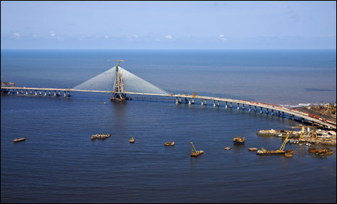
The sea link is an engineering feat

It is the first bridge to be built over the sea in India and it promises to change the skyline of its financial capital, the western city of Mumbai.
The cable-stayed eight-lane 5.6km (3.47 mile)-long, $400m toll bridge links the western suburbs of Bandra with Worli over the Arabian Sea in the southern Mumbai.
It is expected to ease traffic congestion and, according to a state minister, become the city's leading engineering marvel.
Officials say more than 3,000 people have worked to build the bridge, which will be fully thrown open to traffic by June next year.
Paying a $1 toll to travel one way, commuters can hopefully look forward to seeing their travelling time between the two suburbs cut by nearly an hour. At present, more than 120,000 vehicles pass through a narrow causeway on the same route every day.
Building the bridge has posed a number of challenges, say engineers who worked on the project. The main impediment can be rough weather.
Traffic woes
"Effectively, one can work only six to seven months in the open sea. Strong winds and tidal variations make it impossible to supply materials on both sides and it is risky too. We made a temporary pipe along the length for supplying material from one end to the other," says chief project engineer DK Sharma.
Authorities say the bridge is a way to ease Mumbai's traffic problems - the island city with a population of 18 million has more than 1.5 million vehicles.
New railway links, flyovers, an underground railway, elevated walkways and sea transport have been planned.
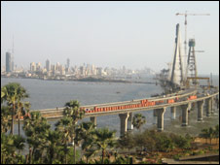
The sea link is expected to change the Mumbai skyline
But the bridge, first planned in the 1980s, is one project that is actually nearing completion.
Critics do not believe the bridge will help ease traffic congestion in a city which adds several hundred new vehicles to its roads every day.
And environmental activists also question the project's impact on the sea bed, marine ecology and livelihood of fishermen - the oldest residents of this island city.
"These deep pillars and unnecessary reclamation on both sides of the bridge will have terrible consequences," warns Girish Raut, an environmental activist who has worked with fishermen residing on two ends of the link.
"Several reports over the years say the coast, mangroves and creeks [in the area around the sea where the bridge is being built] have to be left untouched. The quantity of fish has gone down. At least three beaches have seen the impact with rising water levels but nothing is being done," he says.
Officials say some of these reservations have been addressed - the original plan to build it along the coastline was changed, and the bridge's design tweaked to make it run entirely over the sea.
But some citizens' groups are still not satisfied - they say public transport should be beefed up and the city's thriving railway network extended.
Still, Mumbai's harassed commuters can look forward to improved travelling when the overseas bridge is opened.

Match these definitions to one of the words highlighted:

- held up by metal ropes
- made bigger or more substantial
- metal cylindrical supports, often very high and strong
- opened
- long road bridge over another bridge, or road, or the sea
- fine tuned
- sad problems
- small river
- taking something back

Now answer these questions:

- How would you describe public expectations of this new development, in general?

- What is the official verdict?

- How will travelling into the city change?

- Is the bridge the only thing on the developers’ agenda?

- What drawbacks have been cited?

- Are there alternatives to this wave of development?

Now check your list of terms. Which of these do you think will have been used during construction of this bridge. Give reasons for your answer.

